**Design Consideration**

1. **Add new kind of bike**

- In this additional requirement, we will consider creating new Class call Twin E-Bike with corresponding attributes similar to E-Bike, but changing the Rent Amount of Twin E-Bike in Database.

- For creating new Twin E-Bike instance, we just adding more condition to BikeFactory class to return Twin E-Bike instance if the category in Database is “TwinEbike”:

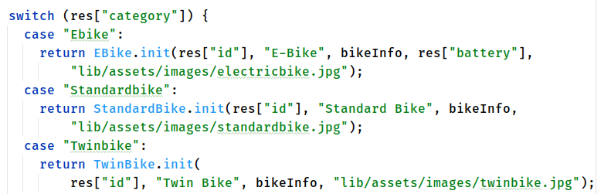

1. **Changing the rental pricing**

- In this additional requirement, we will consider creating Strategy Pattern for 2 renting type:

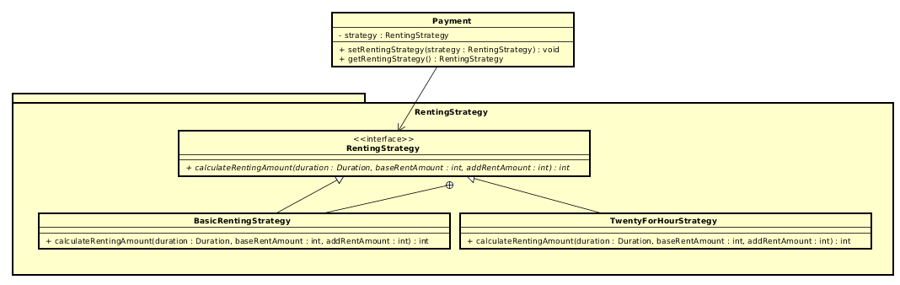

- And for the bike with different renting strategy, we can let the class RentingController to get the different RentingStrategy from Payment model entity and calculate the rent amount of each session.

1. **Add new pause time features**

- In this additional requirement, we will consider in the Rented Bike View Screen to pause counting up the duration. Then the renting amount will not be counted until the user push the button to unlock the bike, the duration will continue.